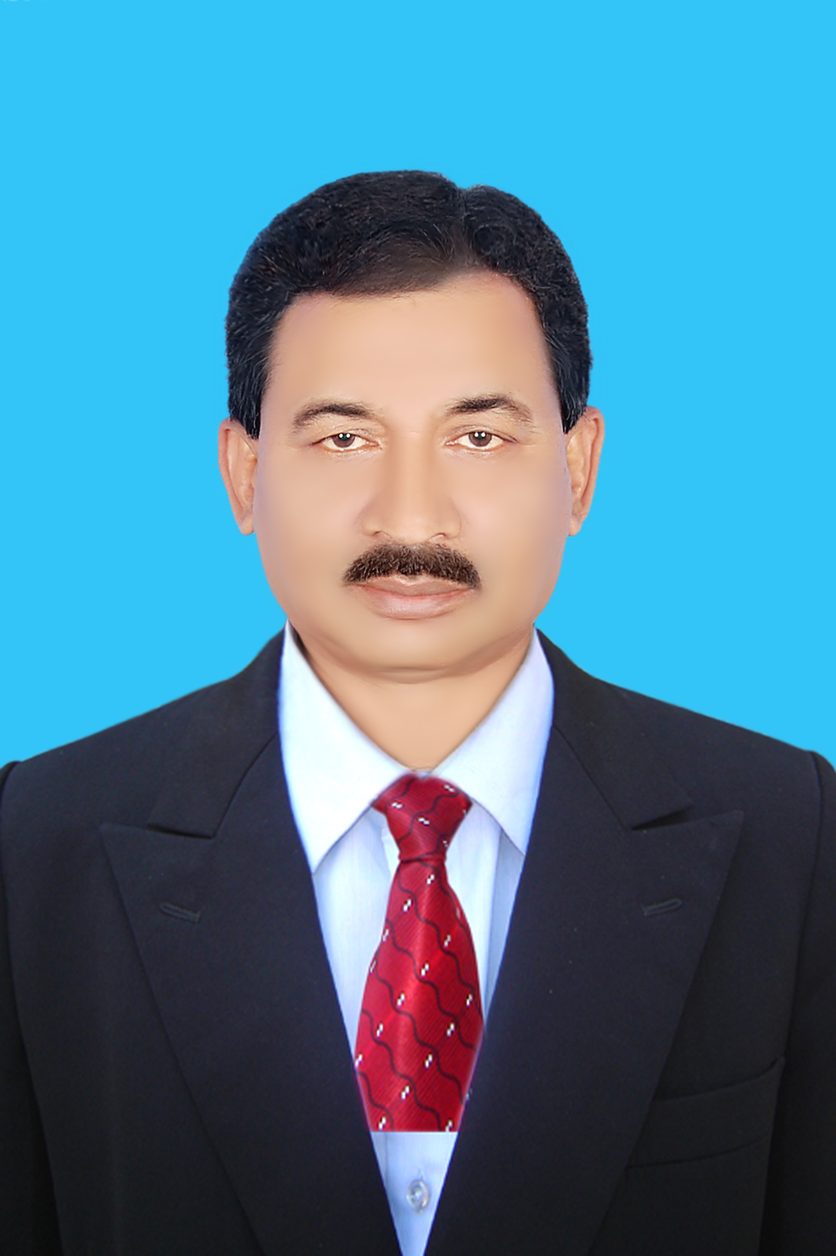

**Curriculum Vitae**

Date: 06 March 2020.

* Basic information:

Name : Md. Abdur Rashid

Father’s Name : Md Abdus Satter

Mother’s Name : Late Begam Hasna Banu

Present Address : 77, Kabi Shukanto Sarak, Bananipara,

Jhenaidah-7300, Bangladesh.

Cell # 01711965445

Email: rashidjhenaidah@gmail.com

Present Address : 77, Kabishukanto Sarak, Bananipara,

Jhenaidah-7300, Bangladesh.

Cell # +8801711965445

Email: [rashidjhenaidah@gmail.com](mailto:rashidjhenaidah@gmail.com), razu_65@yahoo.com

Date of Birth : 1 February 1965

Height : 5’-6’’

Weight : 65 Kg

Marital Status : Married

Religion  **:** Islam (Sunni)

Nationality : Bangladeshi by birth.

* Academic Qualification:

|  |  |  |  |
| --- | --- | --- | --- |
| **Name of the Examinations** | **Board /University** | **Year of Pass** | **Results** |
| S.S.C. (Secondary School Certificate)  Certificatte | Jessore Board | 1980 | 2nd division |
| H.S.C (Higher Secondary Certificate) | Jessore Board | 1982 | 3rd division |
| B.A (Hons) | Rajshahi University | 1985 | 2ndClass |
| M.A ( Master of Arts) | Rajshahi University | 1986 | Uper 2ndClass |
| MDS (Master of Development Studies) | Islamic Univercity, Kustia | 2013 | 3.11 out of 4 |

* **Working Experience: 28 years working in different organization in different position which are as follows-**

1. **Udayan Samaj Kallan Samiti (USKS).**

As a Director Admin 17.07.2019 to at present.

1. **Development for Education and Social Association-DESA**

As a Consultant 10.02.017 to at present.

**2. At AID Foundation**

**i. As a**  **Director, Admin** from 01.01.15 to 09.01.17

ii. As a **Deputy Director, Admin** from 29.04.12 to 31.12.2015.

iii. As a **Admin Coordinator** from 01.11.2010 to 28.04.2012.

iv. As **Program Coordinator General** from01.05.2007 to 30.10.2010

v. As a **Training Coordinator** from10.11.2003 to 30.04.2007

vi. As a **Program Coordinator,** from 01.08.2002 to 09.11.2003.

vii. As a **Technical Officer, from** 12.07.2001 to30.07.2002

1. At BRAC as a **Team In-charge** NFPE Program for 3 Years
2. At HRO, Jhenaidah, as **Program Coordinator** for 2 Years
3. At Mohila College. Shailkupa, Jhenaidah as a Principal for 2 Years .

* **Main responsibilities**:

Project proposal writing, Supervision, Monitoring, Evaluation and to develop guidelines of HRM, Procurements, Staff development for the organizations.

* **Training Received:**

|  |  |  |  |
| --- | --- | --- | --- |
| **SL** | **Name of course** | **Duration** | **Organization** |
| 01 | Self development training | 6 days | BRAC ,Jessore TARC |
| 02 | Training of trainers | 6 days | BRAC ,Jessore TARC |
| 03 | Staff development training | 15 days | BRAC ,Jessore TARC |
| 04 | Nutrition | 3 days | BRAC ,Shatkhira |
| 05 | Integrated rice fish firming & shrimp seed production | 5 days | GTI. BAU  Mymenshingh |
| 06 | Assessment of quality fertilizer | 1 day | BADC Jessore |
| 07 | Seed production & vegetable firming | 3 days | BADC Jessore |
| 08 | Environment development training | 3 days | CAMPE, Dhaka |
| 09 | Arsenic Mitigation | 4 days | NGO FORUM Jessore |
| 10 | Poultry & live stoke | 3 days | AID Jhinaidah |
| 11 | Training on brood Bank Management & Interbreeding of carp fish | 3 days | Aqdp Faridpur |
| 12 | Leader sheep development training | 7 days | VARC Shaver Dhaka |
| 13 | Union Porishod Management training | 5 days | VARC Shaver Dhaka |
| 14 | Training on Participatory Rural Appraisal | 3 days | VARC Shaver Dhaka |
| 15 | Training on Report Card | 5 days | WAVE, Chuadanga,  US AID |
| 16 | Master Trainer Training | 6 days | BNFE |
| 17 | Training on Management & finance | 4 days | MJF |
| 18 | Training on Visit, Supervision, Monitoring and Evaluation | 3 days | AID |
| 19 | Training on project proposal writing and fund rising | 15 days | Organization for Fund Rising |
| 20 | Training on Cow fattening and Goat Rearing | 7 days | Aqdp, Faridpur |

* **Skilled:**

**Training Skill.**

Need Assessment, Project proposal writing, Training Module and Material Developing & Collecting, Training Schedule preparation and Training provide.

**Computer literacy**:

Practical experience In Computer Operating on Microsoft Word, Microsoft Excel and Power Point**.** Web research & Internet browsing.

**Others Skill:** Motorcycle Driving, Communication skilled

* **Language Proficiency:** Bangla is mother tongue

English- Good in writing, reading and speaking.

|  |  |
| --- | --- |
| **Dr A K M Shameem Alam**  Project Director  Department of Agriculture Extension  Ministry of Agriculture  Khamrbari, Dhaka.  Cell: +8801717070736  E-mail: drshameem66@gmail.com | **Md Asaduzzaman**  Professor (Head of the Department)  Accounting Department  Govt K.C Collage  Jhenaidah.  Cell:+8801712900696 |



**(Md Abdur Rashid)**

**Date: 06 March 2020.**